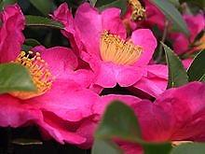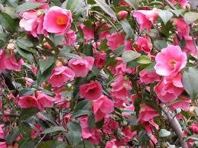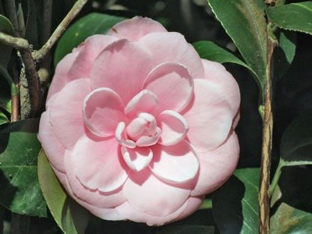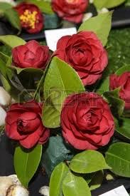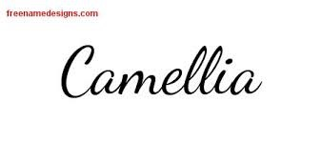

**ENTRY FEE $150 PER TEAM**

**TO ACCOMPANY ENTRY FORM**

**INCLUDES LUNCH & MORNING TEA**

(Please advise of any dietary restrictions on entry form)

(No food may be brought in to the Club without

the prior approval of the CEO)

Entries close 1/6/2019



**ALL ENQUIRIES TO THE SECRETARY**

**Lynne Tarrant**

**PO BOX 19 URUNGA NSW 2455**

**PH: 0400155634**

**Email: womens.bowls@urungabowlingclub.com.au**

**URUNGA WBC**

**PRESENTS**

**CAMELLIA TRIPLES**

**CARNIVAL**

**2019**

**TOTAL**

**PRIZE MONEY**

**$3,450.00**

**1ST - $1500**

**2ND - $900**

**3RD - $600**

**4TH - $300**

**5TH - $150**

**JUNE**

**8 & 9**

**CONDITIONS OF PLAY**

**3 BOWL TRIPLES**

**SATURDAY - 3 GAMES 11 ENDS**

**SUNDAY - 2 GAMES 11 ENDS**

**ONE TRIAL END EACH GAME**

**NO DEAD ENDS, JACK TO BE RESPOTTED ON T**

**A DRAW REMAINS A DRAW**

**WINNERS DECIDED BY WINS & ENDS AND THEN MARGINS IF NECESSARY**

**NO SINGLE DAY ENTRIES**

**In the event of inclement weather at least 7 ends must be played to constitute a game, game will then be scored on the greatest number of ends played by EVERY team**

**THE COMMITTEE RESERVES THE RIGHT TO VARY THE PROGRAM AND CONDITIONS OF PLAY DEPENDING ON WEATHER OR OTHER CIRCUMSTANCES**

**BA LOGO TEAM CLOTHING**

**MORNING TEA AT 8:45AM…PLAY COMMENCES 9AM**

